**Lesson07 Apply Jump Server**

**Notes: -**

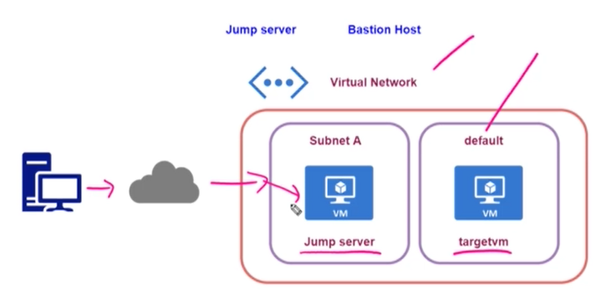

**\*We have to remove public IP address from default subnet that holde AZ VM that hold app server**

**\*We have to apply public IP address into subnet A that its jump server that connect with the default subnet that hold resources**Steps:-

**Steps:-**

**1-on the Azure VM > Network > click public IP Address > click deassociate publich IP address**

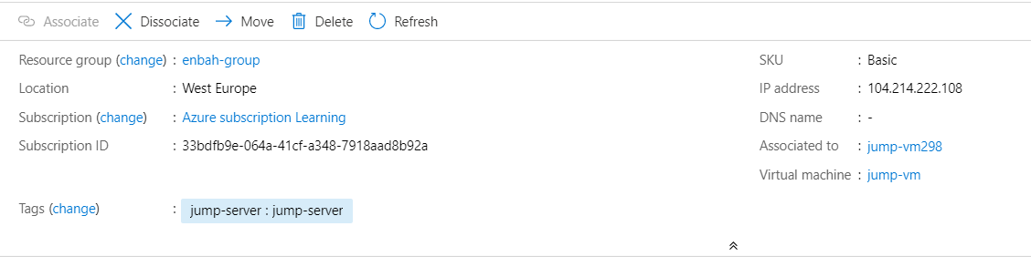

**2-on all resources delete the publich IP address of the default subnet**

**3-create new jump vm with create new subnet and apply IP address**

**4-on the jump VM > network > add new inbound roles Http and update RDP role**

**(source = Publich IP address Wifi , dest = private IP address of jump server)**

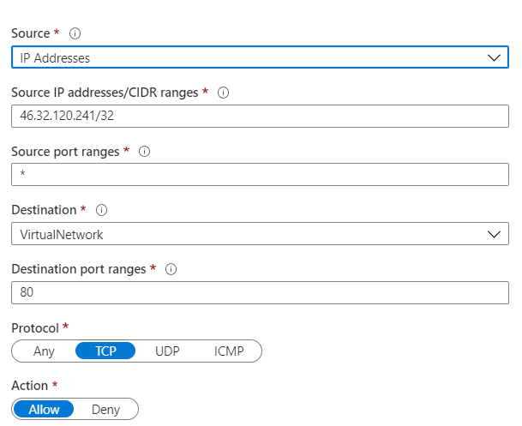

5- RDP inbound role to accept from source public IP address and redirect to private IP address

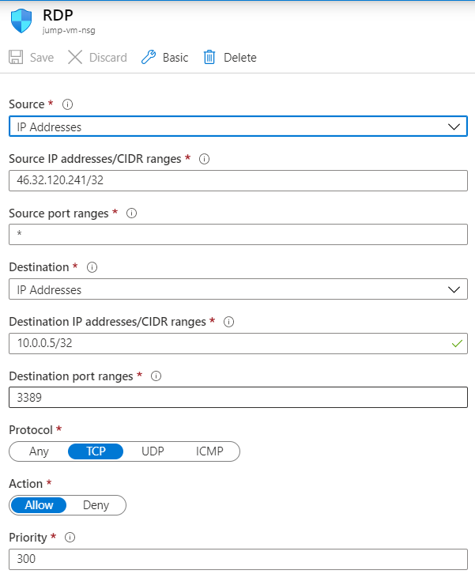

**6-on the default VM > Network add new inbound role http and update RDP**

**(source represnet = private IP address Jump server , dest represetn = private IP address default VM)**

